
Micad Reports
14/05/2025
Document Version 1.4
Contents
Introduction to Micad Reports 2
What are Micad Reports 2
What’s new in Micad Reports 2
Micad Reports 3
Accessing the Micad Reports service 3
Reports service homepage 4
Search for a report 5
Run a report ad hoc 6
Generate tab 6
Save and reuse the report data and format 8
Report delivery 10
Report Activity tab 11
View the report 12
Schedules tab 14
Add schedule wizard 15
Schedule settings 16
Schedule parameters 17
Schedules list 19
Designer 20
Create a custom report using ‘Designer’ 21
Configure data 22
Editing a field 23
Aggregating a field 24
Creating a custom field 25
Static text 25
Calculation 26
Formula 27
Editing a custom field 29
Using a custom field 29
Order data 30
Configure filters 30
Preview & publish 32
Generate your Designer report 33
Available topics on the ‘Designer’ 34
Release notes 35

Introduction to Micad Reports
This guide is specific to Micad Reports and provides an overview of its key features. As the application evolves, this document will be updated accordingly. Details on new features and fixes will be listed in the final pages with each subsequent release.

What are Micad Reports
Reports serves as a central platform for accessing data from Micad Applications and professional modules. It provides a single point of access via the Micad HUB, allowing users to collaborate and share information with partners and service providers in a read-only format. Reports and data are accessible from both desktop PCs and mobile devices.
Reports can be run on demand or scheduled to run automatically. Users can easily select their topic from the left-hand menu or by using the keyword search feature. They can choose from a variety of pre-existing reports or create custom reports using the 'Create with Designer' option.
The 'Designer' tool, available as an additional feature with an extra purchase, guides users through a step-by-step process to create either private or public reports, depending on their permissions. Only report admin users have the ability to create public custom reports, which are shared with all clients within their organization. Users can save, copy, and share their ‘Desginer’ reports with others. Once a report is saved, it can be run ad hoc or scheduled like any other report.

What’s new in Micad Reports

- New technology many legacy limitations are removed
- Unified 3rd generation UI
- Unified centralised security ‘Single Micad’ login and SSO
- The data displayed is live immediately
- System load impact is moved away from the application module
- Scheduler wizard
- Mobile support with responsive design
- Multi tenancy architecture
- New flexible URL structures facilitate sharing and integration with third parties
- Superior and more durable backend infrastructure
- Ability for the user to create custom reports with Designer

Micad Reports

Accessing the Micad Reports service

Access through Micad HUB by:
- Selecting Reports & Data Exports tile,
- or changing the current application to ‘Reports & Data Exports’


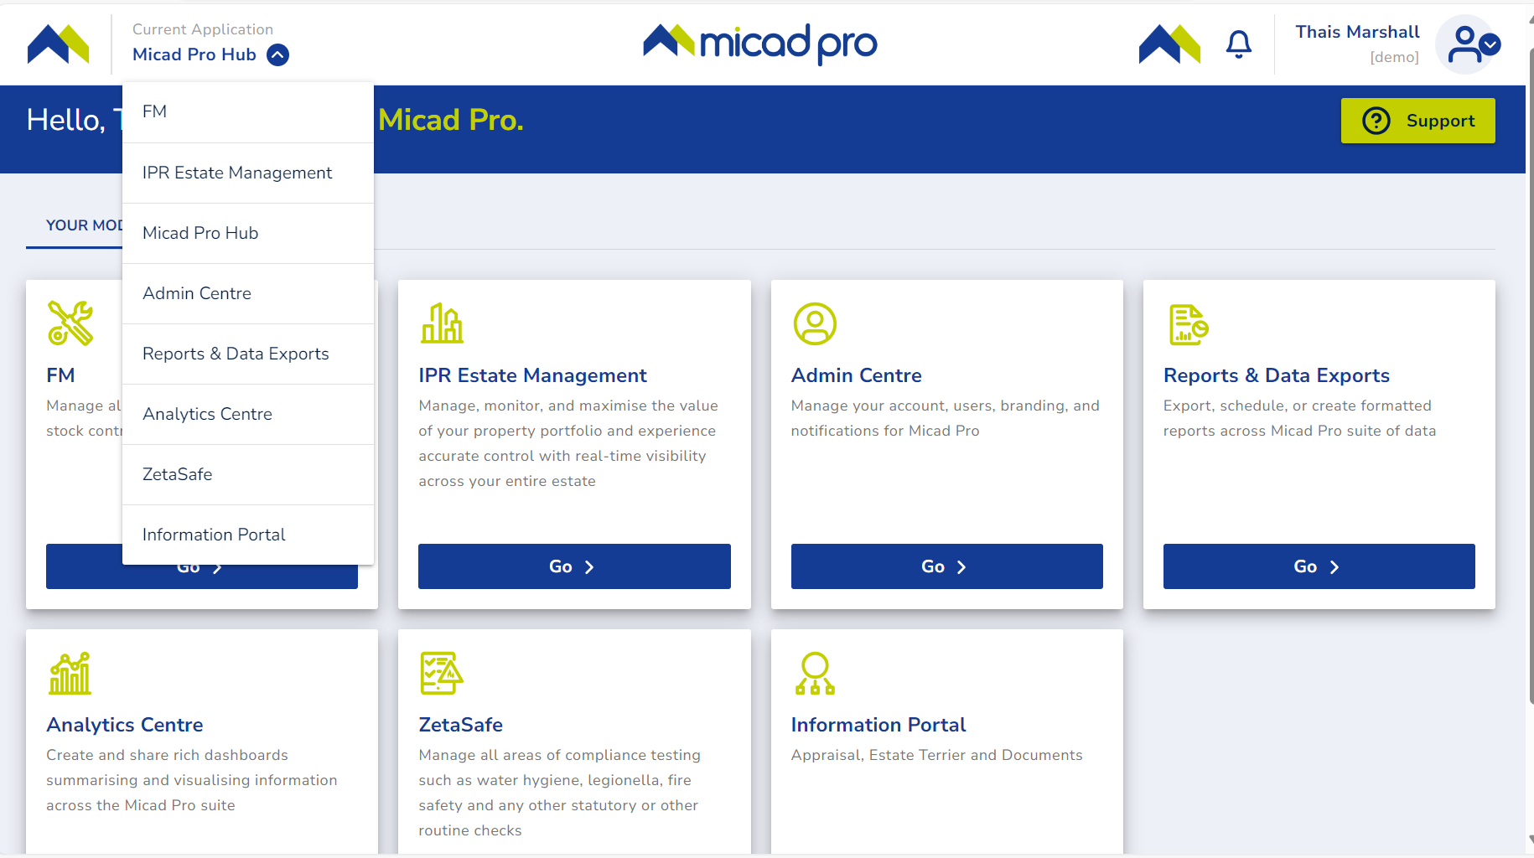

Reports service homepage

Once you enter the Reports service the homepage layout will appear.






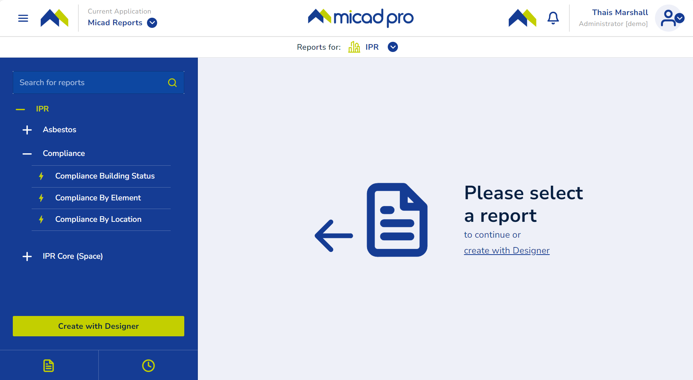
11
10
9
- Current user account login, access to user details and to ‘About’ page with release date and product version.
- Reports notification feature.
- Application selector.
- Show/hide left-hand side menu.
- Report search feature.
- Tree view control (showing – represents expanded, + represents collapsed).
- Reports icons (lighting bolt represents pre-existing report, star represents custom reports created with ‘Designer’)
- Reports list.
- Access to ‘Designer’ feature.
- Reports Activity, shows all reports (in your current user profile) already delivered.
- Report Schedules, shows all reports (in your current user profile) already configured.

Search for a report

Use the search feature to track a keyword related to your report subject.
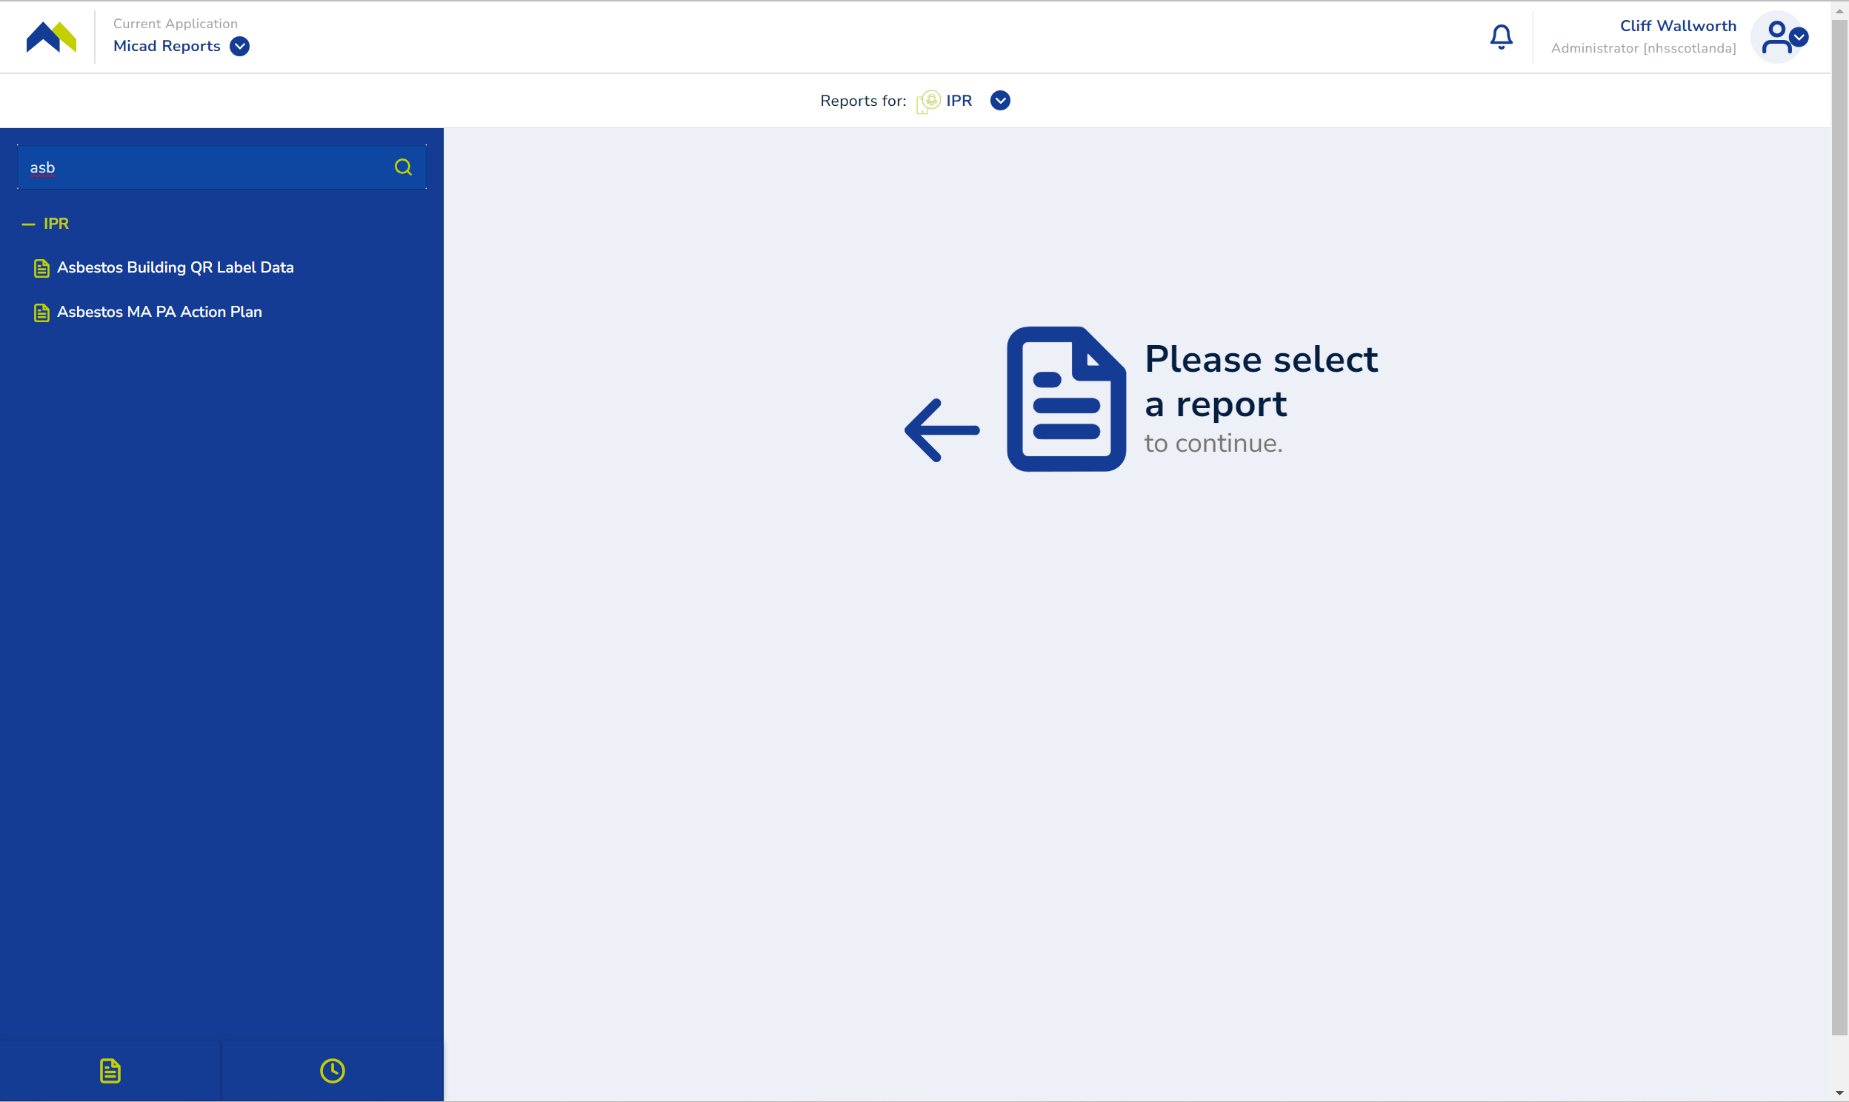
Click in the "Search for reports" text box and begin typing your keyword. As you type, the list will filter to display reports that match your search criteria. If no matches are found, the pane will appear blank.

Run a report ad hoc

Once the reports is visible in the left menu, you can request it to be run ah-hoc
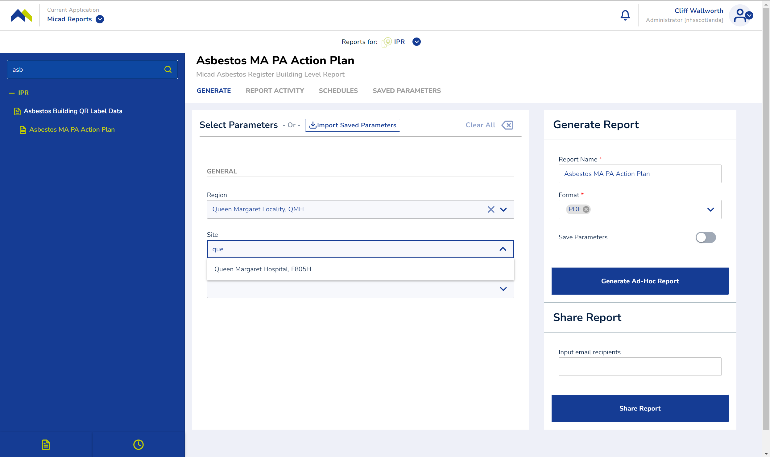
The report generator requires parameters, this asbestos report must be executed from building level

Generate tab

Click on the name of the report you wish to run. The report generator will appear in the central panel, where you can define the parameters for the specific report. Under the General tab, select the desired locations for the report. Each level features a dropdown menu displaying locations from the IPR system. The available selections are determined by the report's specifications.

Note. Report parameters are defined by each report, maybe a location-based report might require to be run at site level. The concept of location-based reports is common throughout the IPR and its professional module. When a report is designed, a description and level narrative will be provided by the developer or party that specified it.

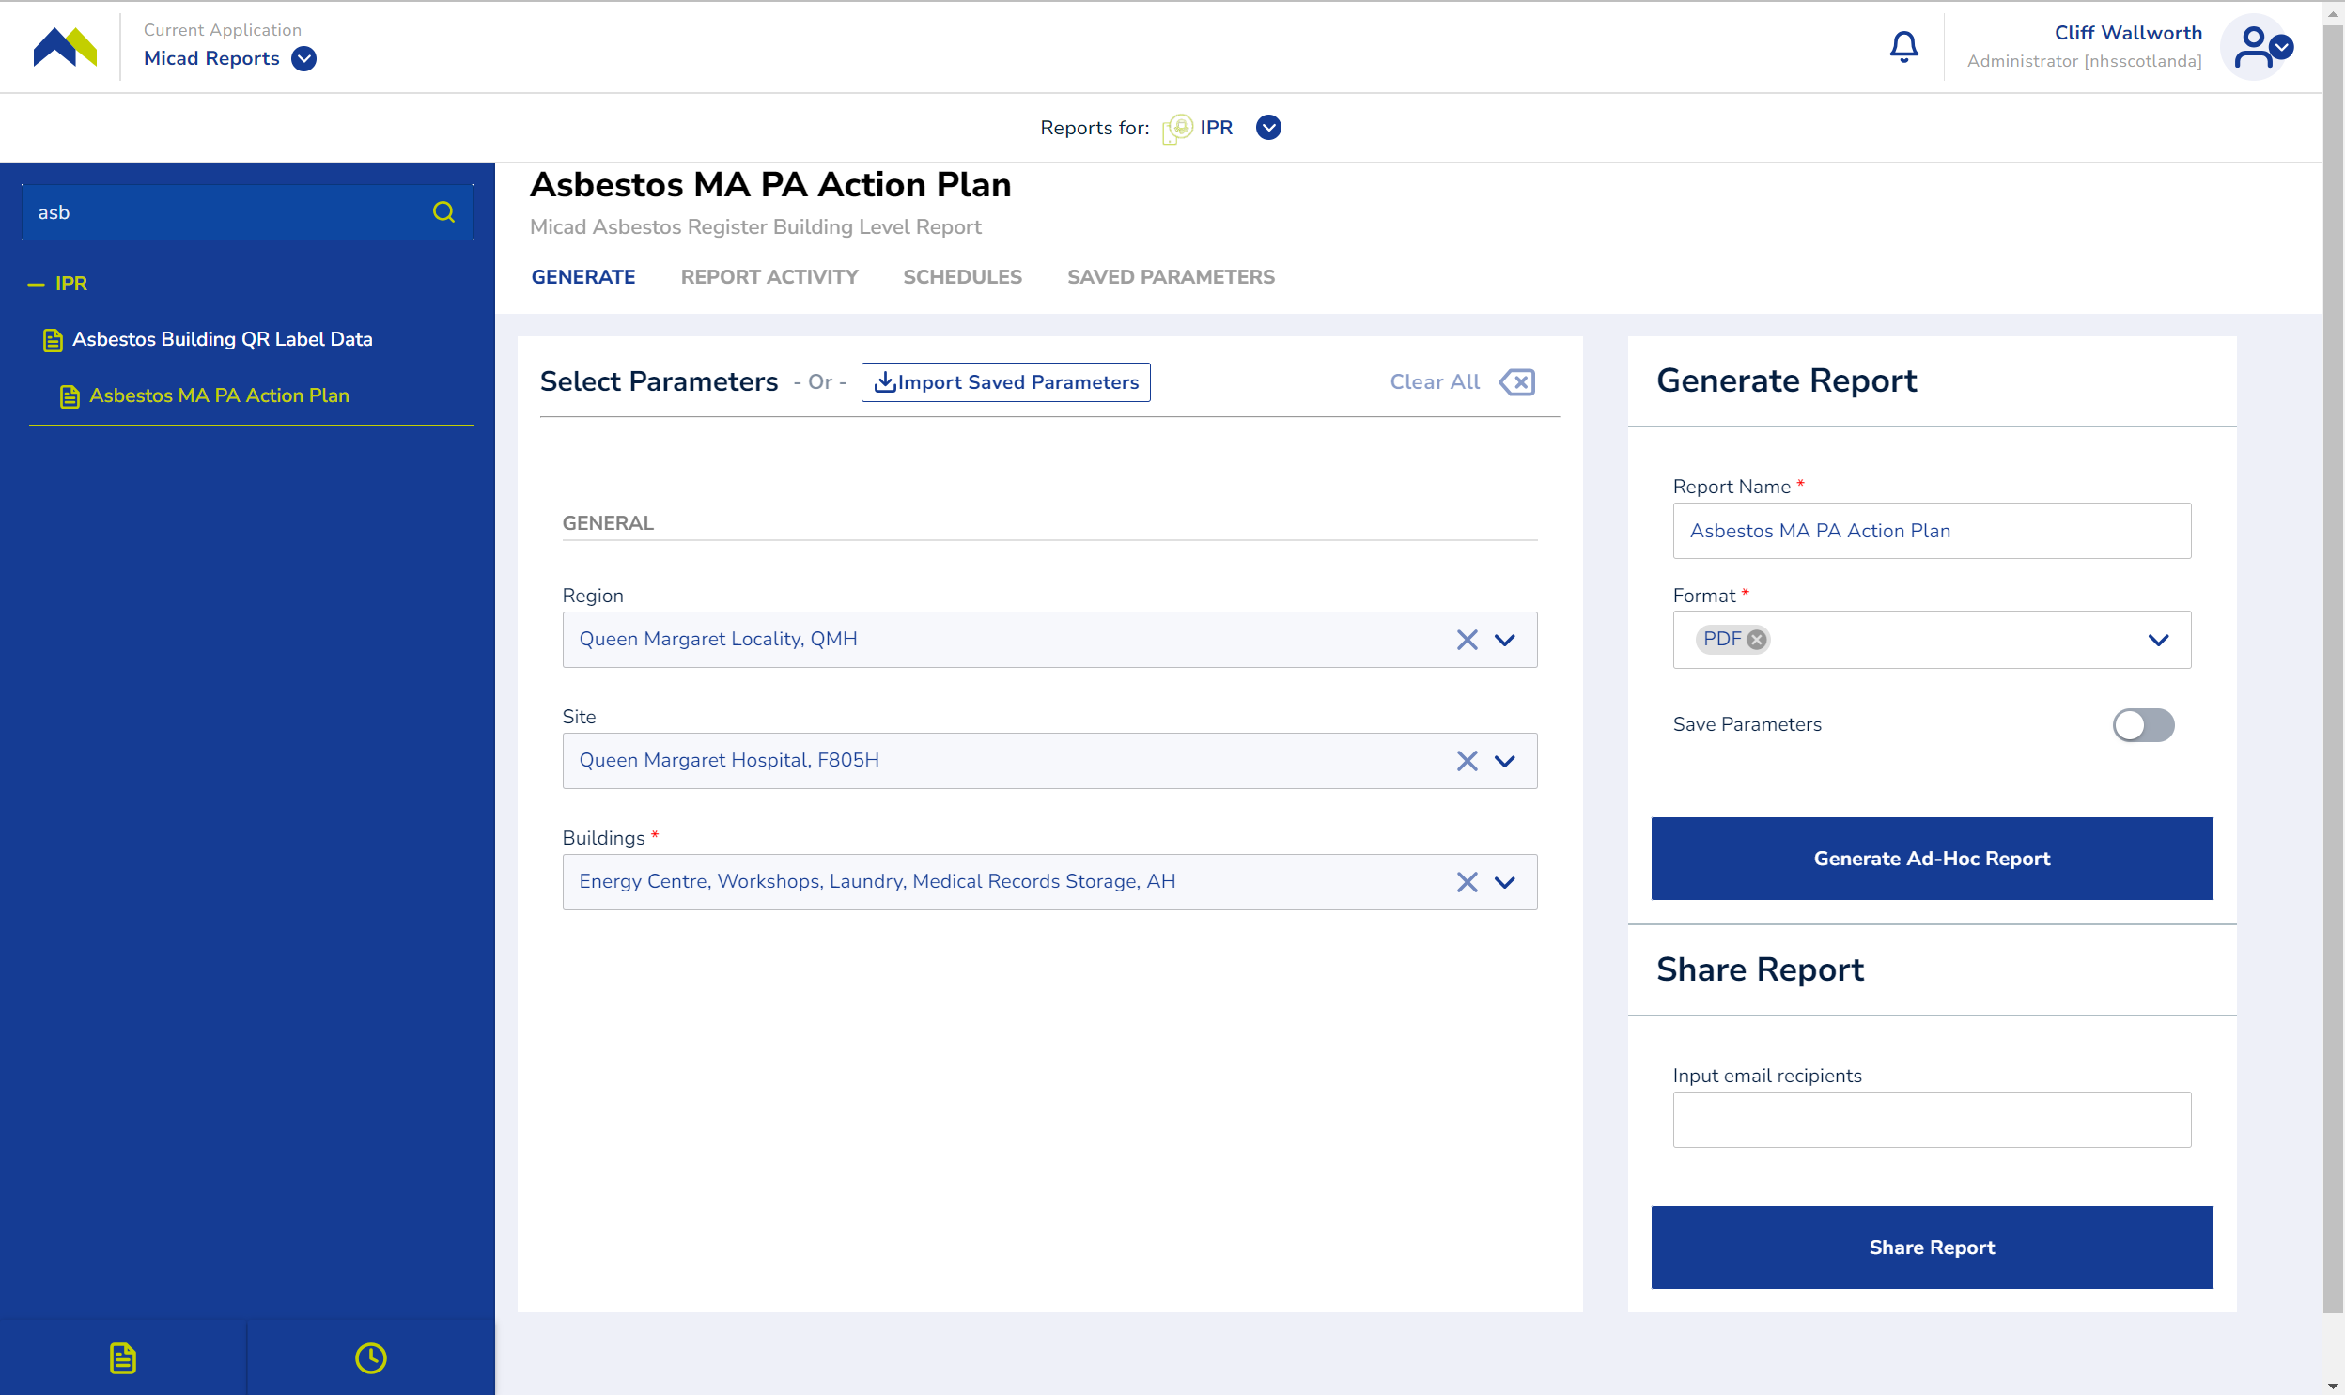
- The red star (Buildings) indicates this is a mandatory level by design
Each of the levels requires a location selection, working from the top (Region) each level will progressively disclose the property hierarchy.
You can scroll through the lists or if you know the name or code, just type in the text to speed up the selection process.
- If you make a mistake, you can quickly clear all selections, Click the Clear All icon in the top right of the Generate tab.
- You can edit the title of the report at this point.
- Choose the format of your report.
- You can execute the report with this minimum of information. Click ‘Generate Ad Hoc Report’ to execute the report.

Save and reuse the report data and format

To get more value form the report, save the parameters, detail it or email it out.
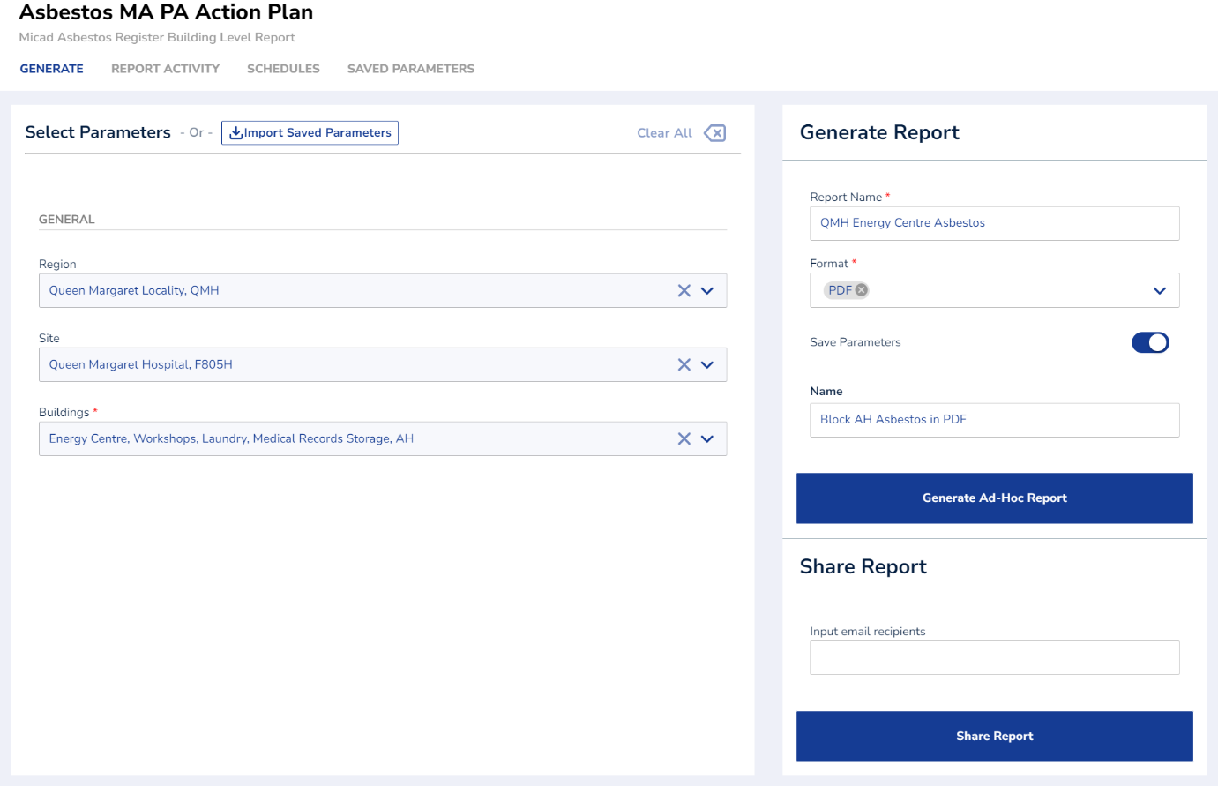
Names and parameters are helpful with repeating tasks

In the section Generate Report:
Use Report Name so that when the file is created it appears in the Report Activity list and each occurrence can be differentiated for the data it represented.
Name the Save Parameters appropriate to the location data the report file will use.
In the section Share Report:
Carefully add each valid emails address in the Input email recipients field. Press enter after each one and the system will capture each as you go forming a list. If you make a mistake, click the X to remove it.

The Ad Hoc feature, used to its full potential.
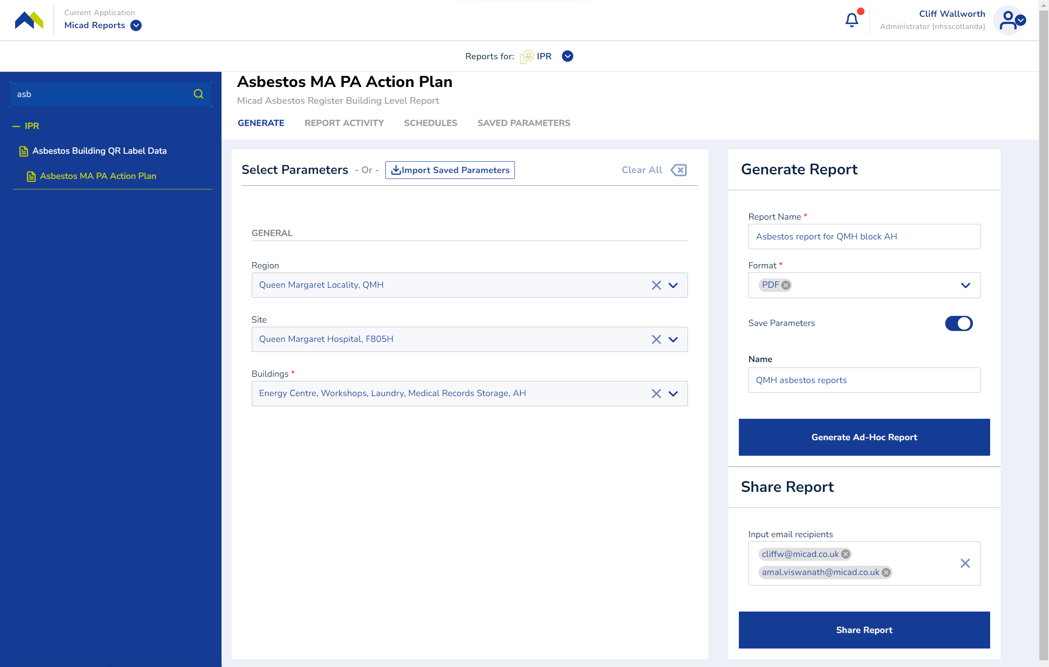
Example shows how the name parameters and email might be used

To execute the report and save it in a specific name and/or save its parameters. Click Generate Ad Hoc Report.
To execute the report and send copies in email to the named recipients, Click Share Report.

Report delivery

Soon after the report is executed, a confirmation will be visible on the Report Activity tab. If the report was sent by email, it will arrive shortly after.
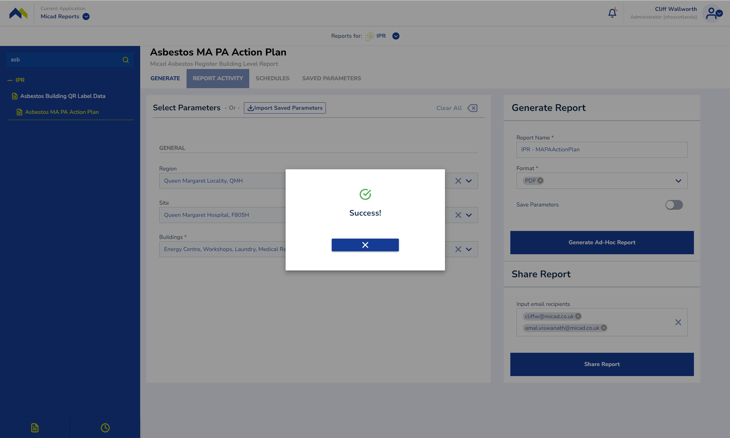
Observe the Report Activity tab flashing briefly. The notification bell will show a red spinner

The report is now being generated in the background.
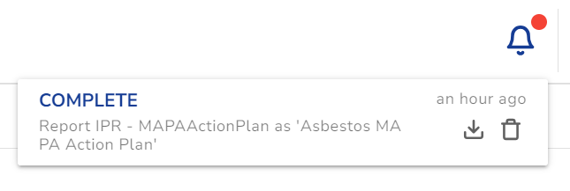
Once you see notification marked with a solid red icon, you can then click to download the report. Use this feature to develop or check your report is correct, this means you do not have to leave the screen where you are setting and naming your parameters. You can delete the report until the correct data is achieved.

Report Activity tab

Use the report activity tab to access all the reports that you have previously executed.
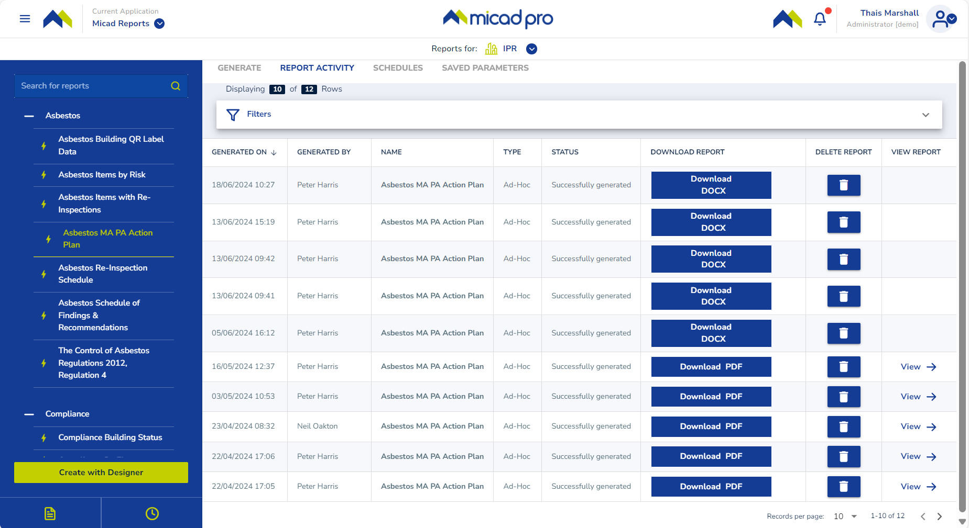
A history of output files generated by Micad reports

You can navigate through the files, sort the table by columns, and download any historical report. Use the page breaks for easier viewing.
This page displays key information about each report, including the date it was generated, the user who generated it, the report title, type (ad hoc or scheduled), status (Successfully Generated, Queued, or Failed), as well as buttons for downloading, deleting, or viewing PDF reports directly on the page without needing to download them.
To download a report, click the Download button, which retrieves the stored version generated on the specified date. This copy reflects the data from the system at that time.
To delete a report, simply click the Delete icon to remove the stored copy.
Note: In this example, the selected report is an asbestos report titled Asbestos MA PA Action Plan. The Report Activity section only shows the history of running this specific report. To view the history of all reports you've executed, use the icon located at the bottom left of the menu, which will display all previously run reports.

View the report

Use the View button to quickly preview the report output if report was run as pdf. The visual format of the report varies between file technologies.
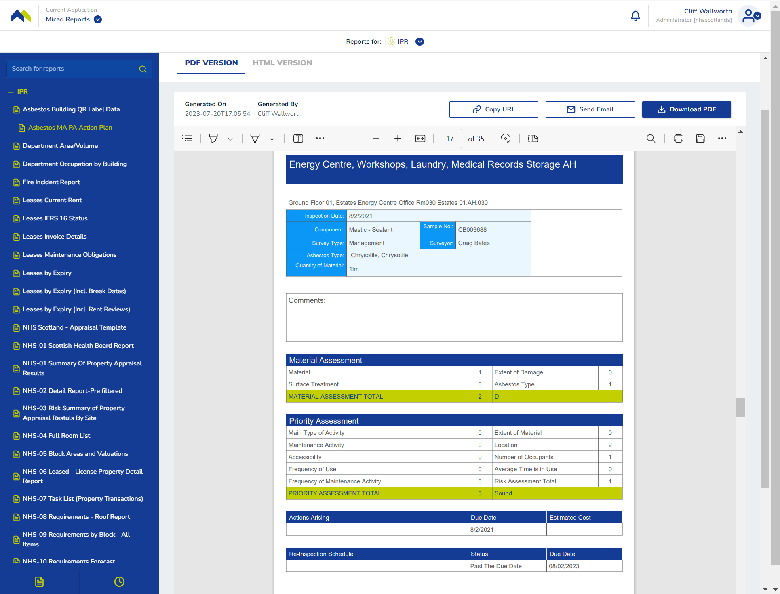
Example show a PDF and uses the embedded web browser’s PDF technologies and feature to preview

Use the Copy URL button to share a direct link to the report data file (PDF in this example).
Use the Download button to take a copy of the report data file from the system.

Use the Send Email button to share a copy of the report data file from the system.
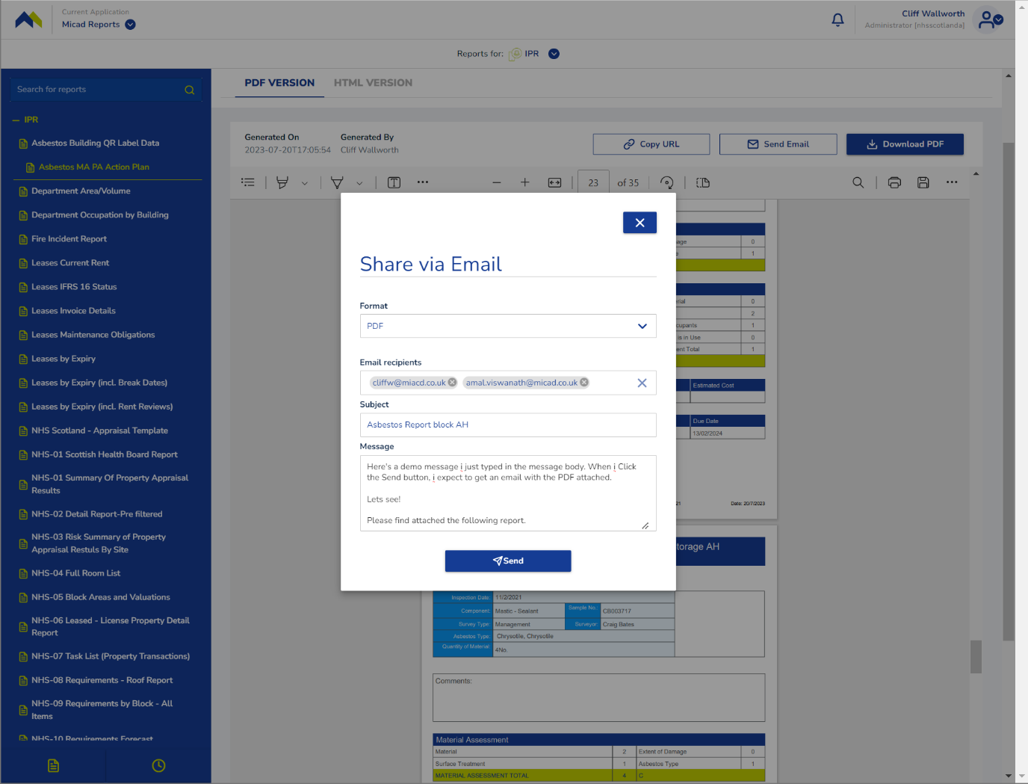
Share the report data file direct from the preview screen

Fill out the Share via Email fields, click Send when done.
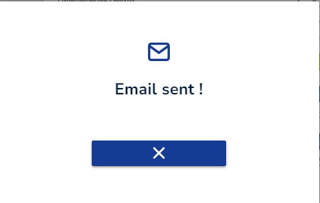
An email will arrive in the inbox of recipients. Look for a sender no-reply@micadnotifications.co.uk
Note. You must make sure that the email address you type is valid. The system assumes that email addresses can be used from any domain, not necessarily valid system users. In the test above, there’s a typo in a domain name, only one recipient received the email message. You will not be alerted of non-delivery.

Schedules tab
To add a recurring schedule to an existing report format, in the Report Activity tab, Click the Schedules tab.
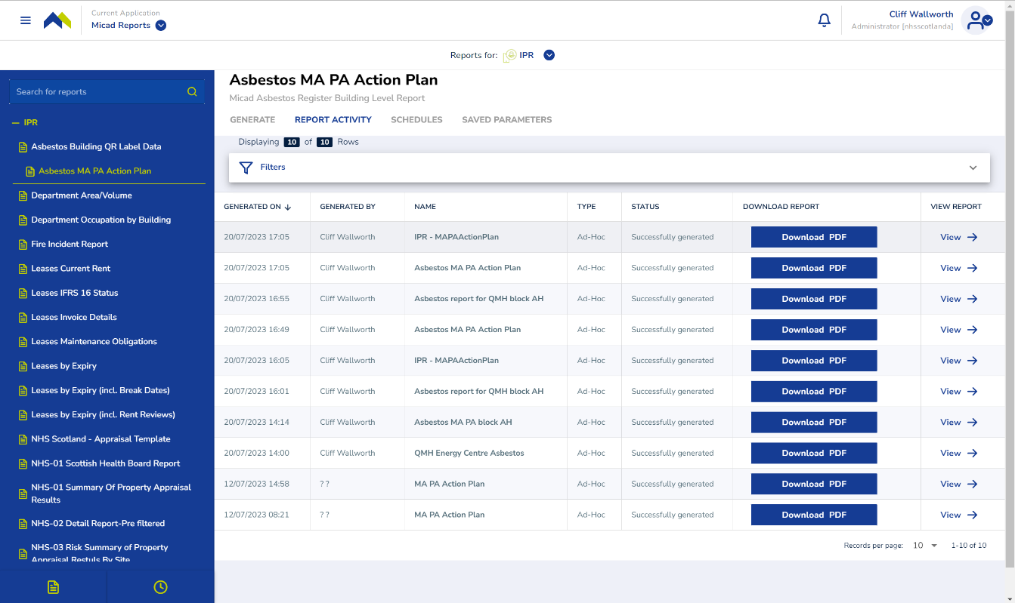
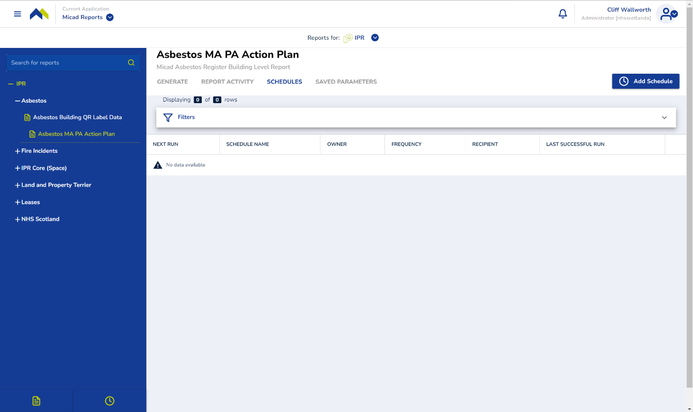 Click the Add Schedules button to start the schedule wizard process

Add schedule wizard
Fill out the 3 stages of the wizard.
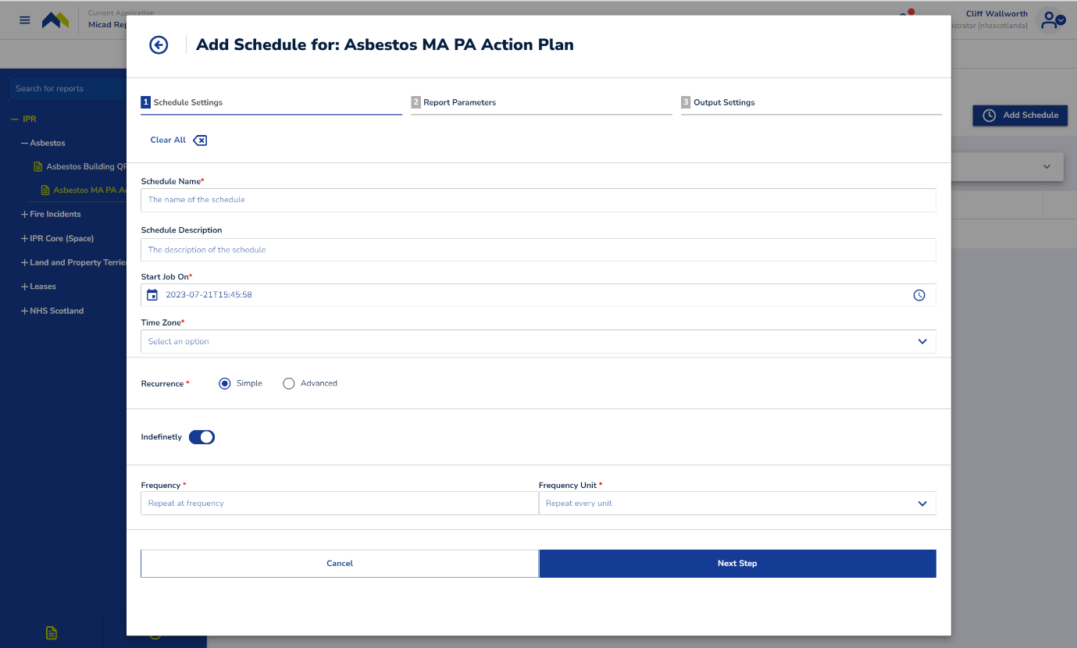
Fill out a Schedule Name
Schedule Description is optional but think of using consistent terminology
The specific date and time is need for the schedule, Start Job On
A Time Zone must be specified
You can choose to express your scheduler setting in Simple or by using Advanced options.

Schedule settings
Carefully fill out the settings. To exit the wizard click anywhere outside the popover window.
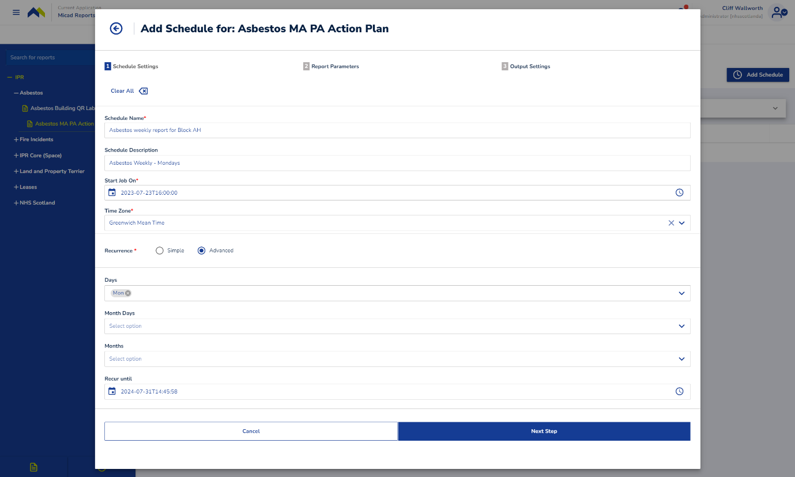
Click the Next Step button to continue.

Note. Make sure you don’t inadvertently click outside the popover window by mistake, this aborts the wizard immediately and any input is lost.

Schedule parameters
Check or set the parameters. Parameter for this report are its property location, these will vary or there could be none depending on the specific report
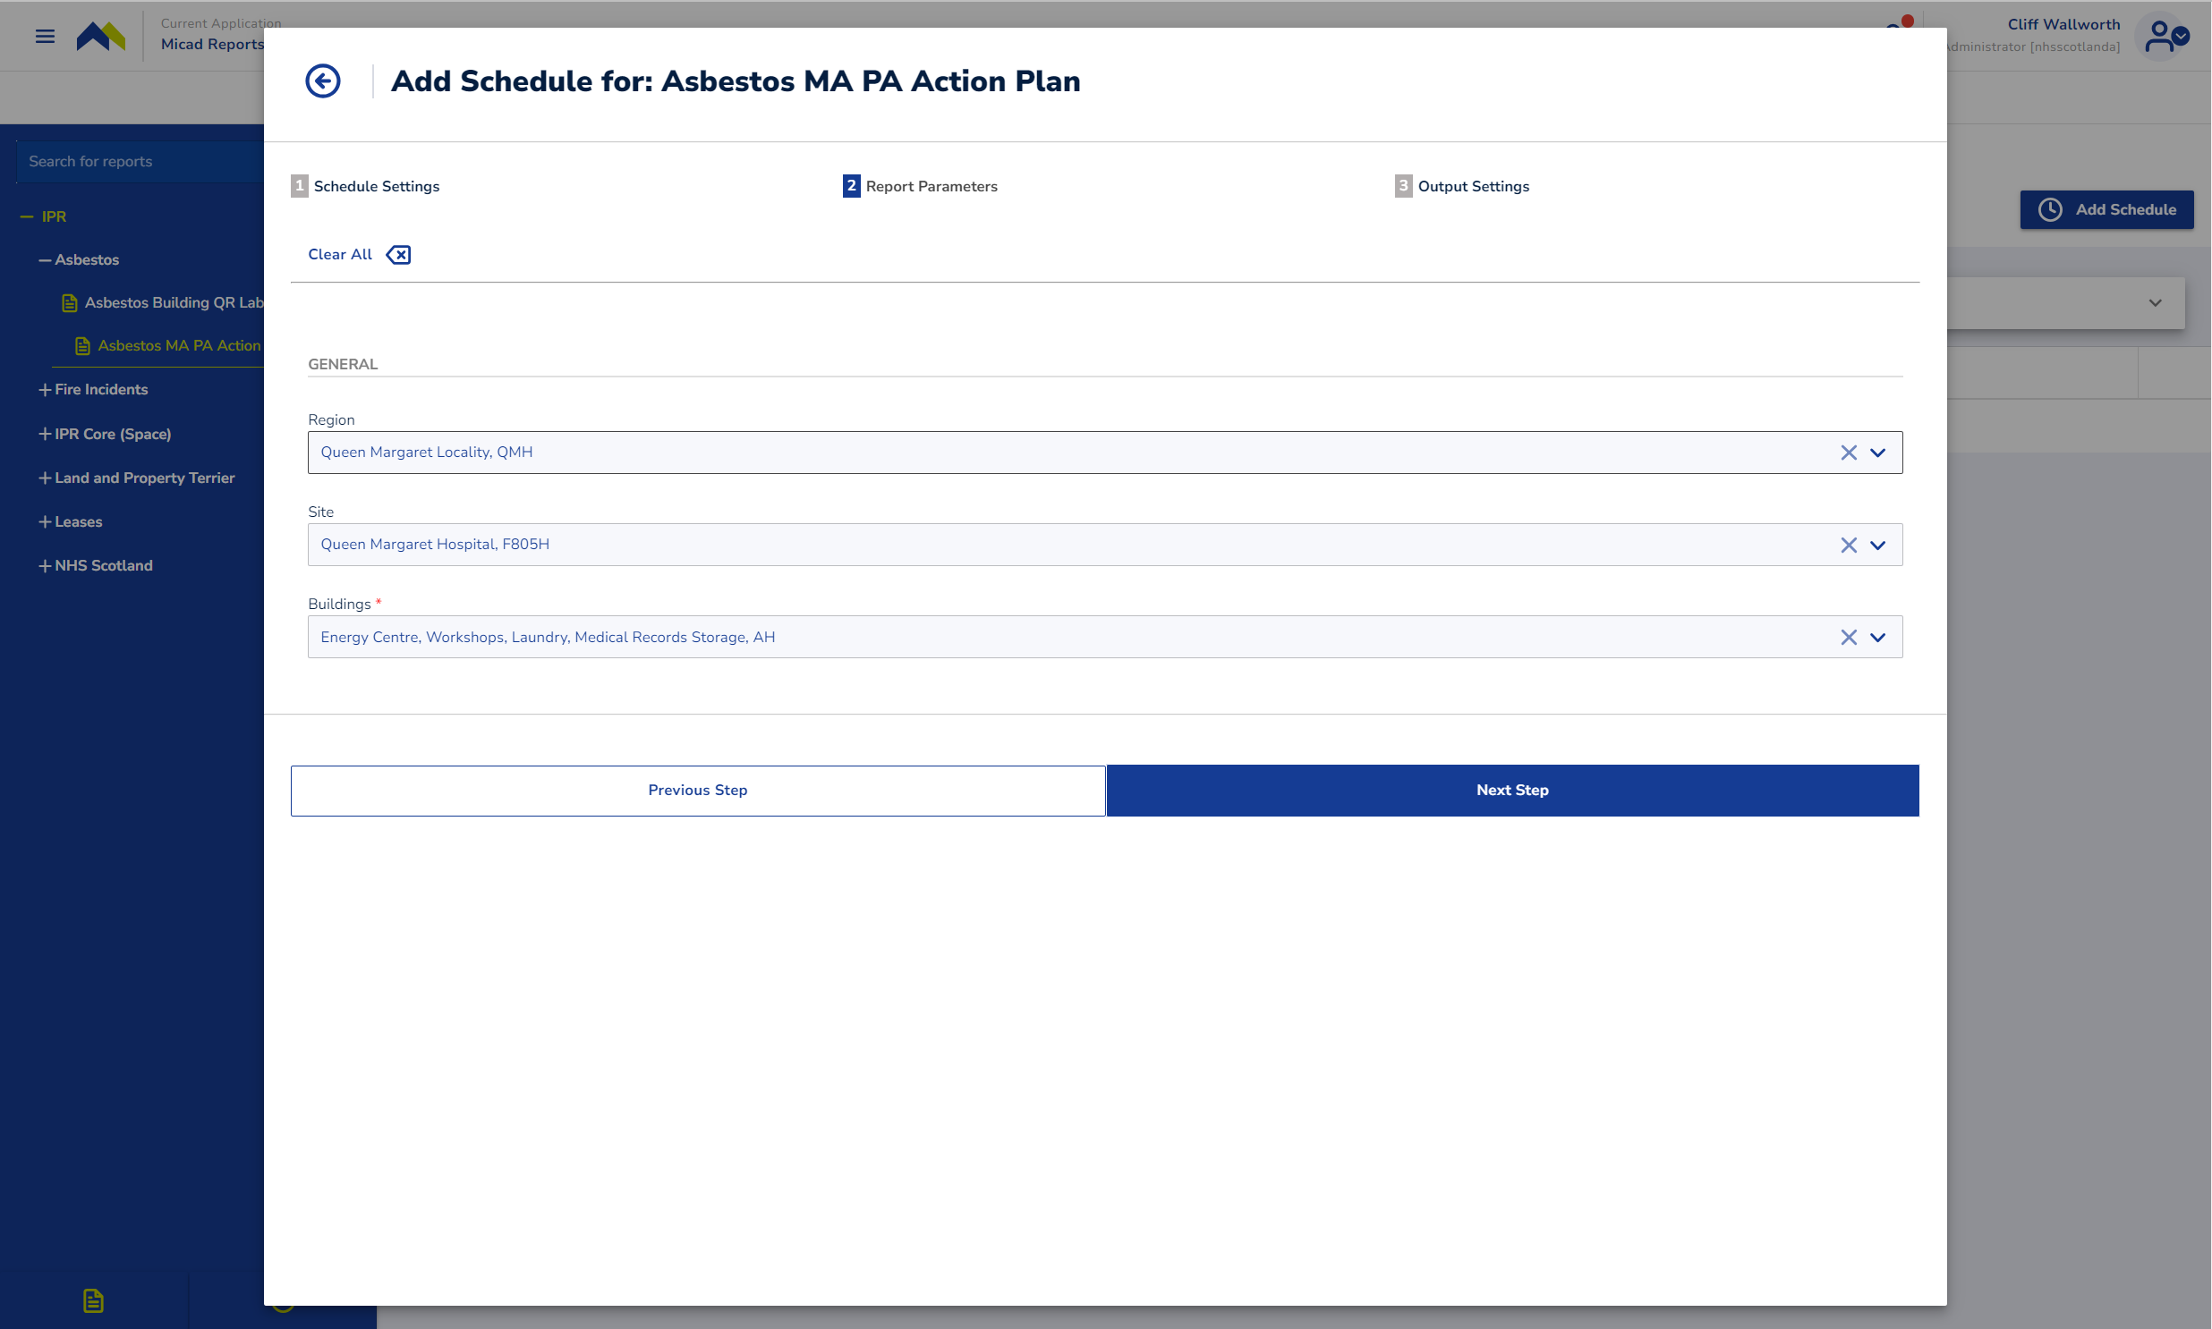
Click Next Step
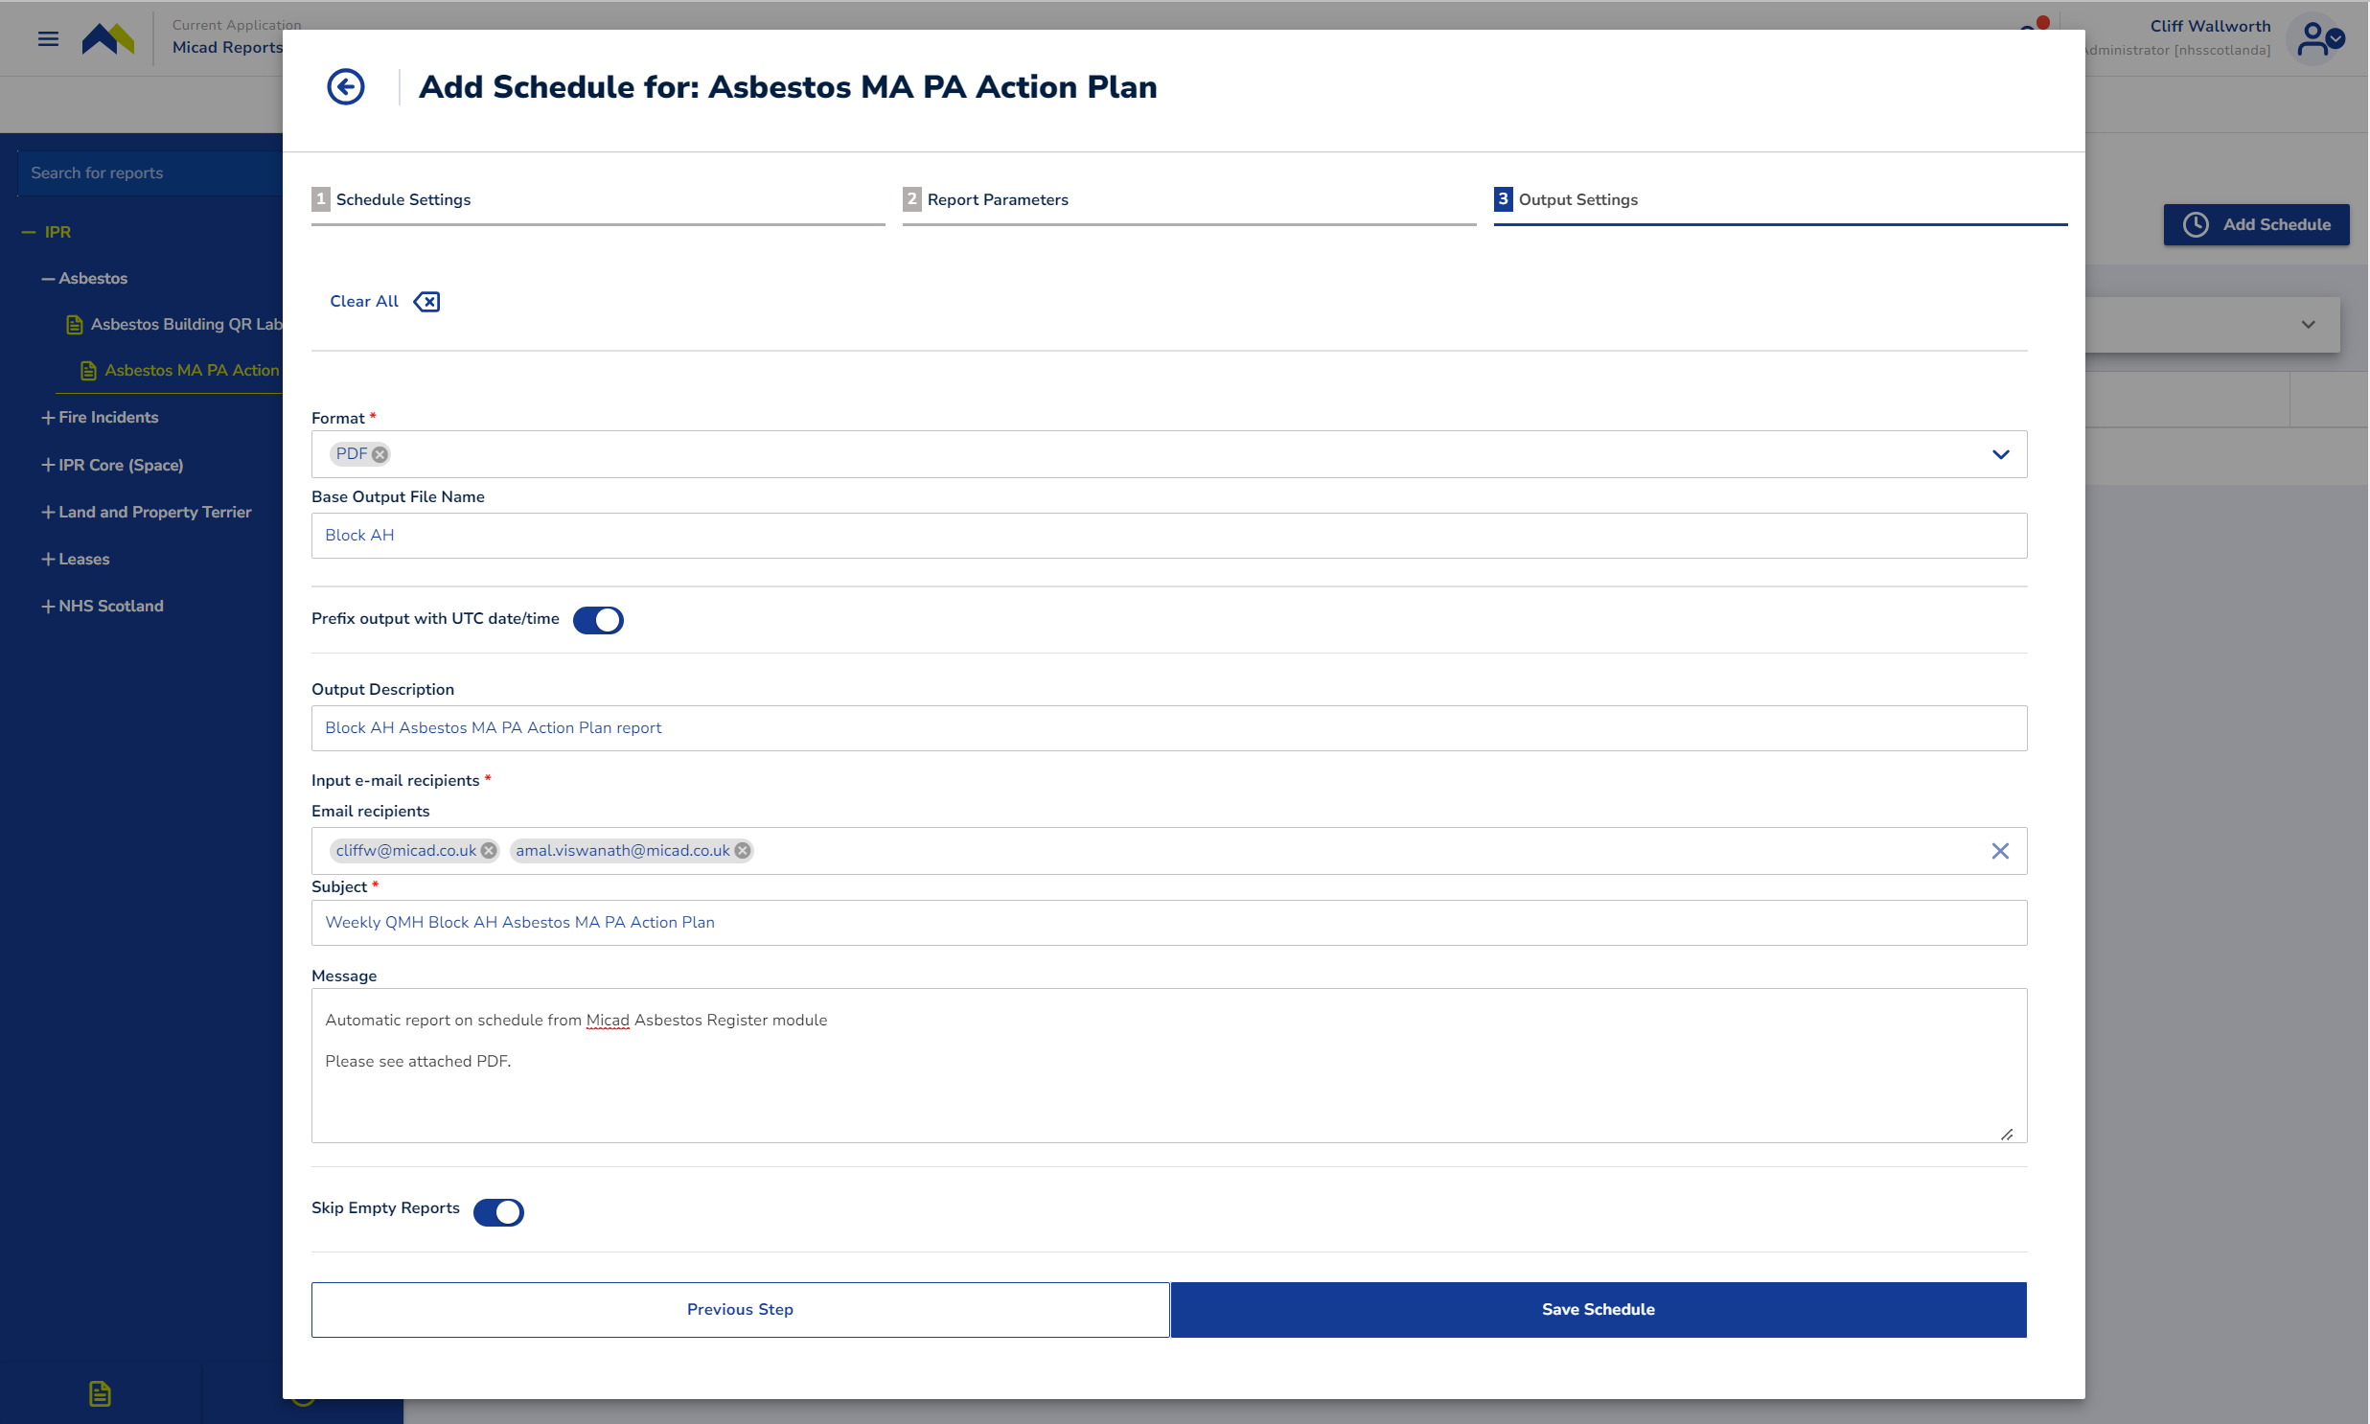
Choose Format and fill out the email settings. Click the Save Schedule button
Success, the schedule was completed and saved.
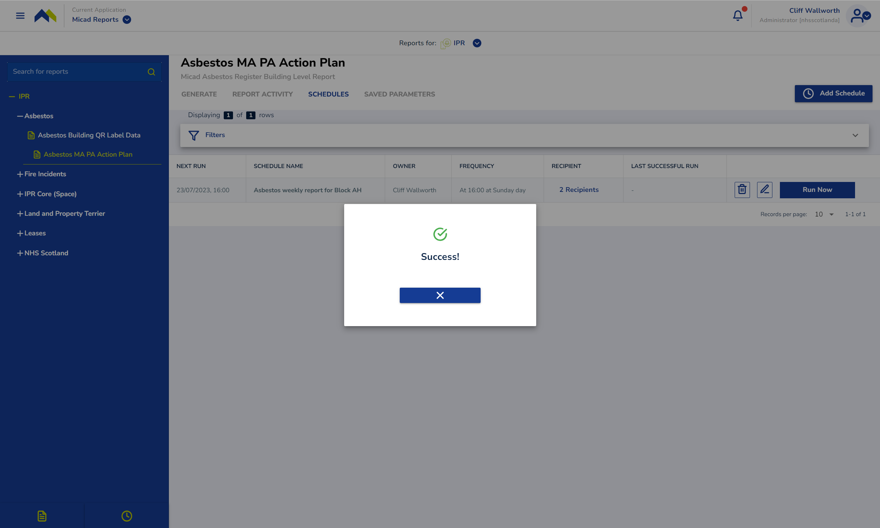
Example shows a schedule plan that will first execute on23/07/2023

The schedule is now programmed to be delivered by email.

Schedules list

Use the Schedules list to review and edit your report schedule plans
Can also access the Schedules list direct via the Clock icon in the footer of the left menu.
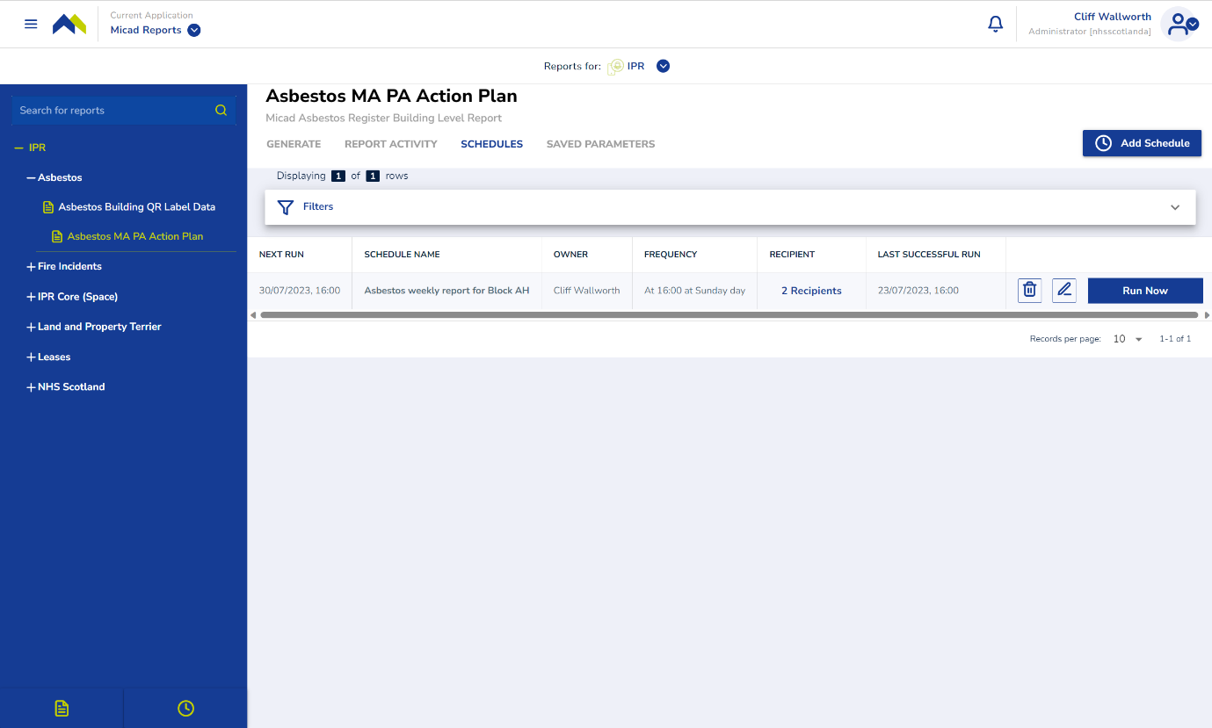

Click on the Edit icon to change the schedule plan details.
Click on the Delete icon to remove a schedule
Click the Run Now button to test your schedule plan will deliver emails

Designer

‘Designer’* is a powerful reporting tool which provides users the ability to create their own custom report by choosing fields and parameters within a topic of their choice. Users can also create custom fields with calculations of existing fields.
Limitation: custom reports are limited to 10,000 rows.
To create a custom report, select ‘Create with Designer’ button at the bottom of the left-hand side menu, or in the centre of the page.
You’ll be prompted to follow a step-by-step guide to create your custom report.

*This feature is only available to the following report user profile/roles: report admin and user; report viewer can only see public ‘Designer’ reports created/shared by admins, they cannot create a custom report themselves.

Create a custom report using ‘Designer’
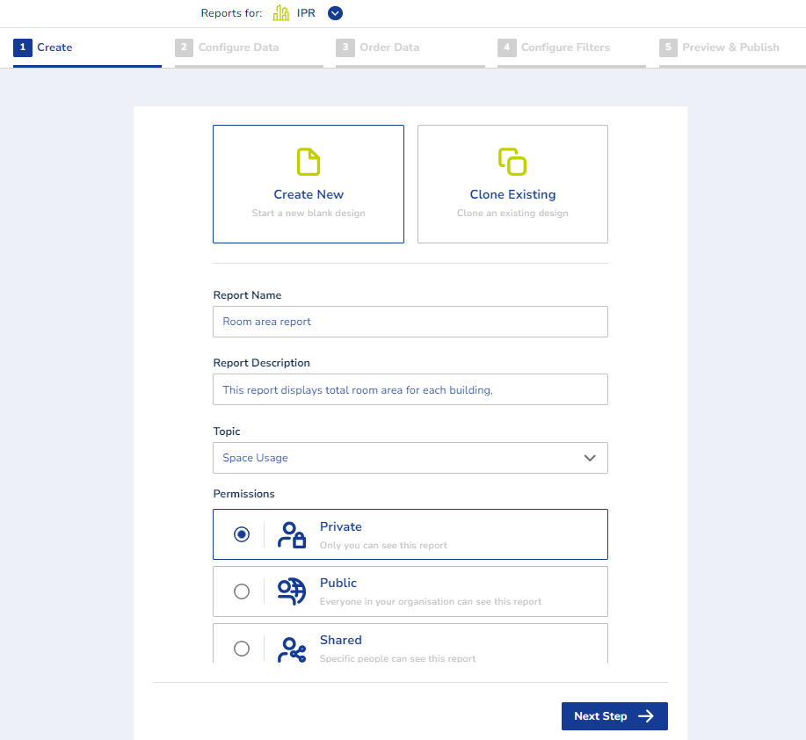
In the first step, you can define details of your custom report such as if you’d like to start a new report or clone an existing custom report (also created via ‘Designer’), report title, description, topic and permissions.
Permissions are as follows:
- Private: only you can see the report, this option is available for report admin and user.
- Public: everyone in your organisation can see this report, this option is available for report admin only.
- Shared: only specific people can see this report, this feature enables a report user to share a custom report they created with an admin and request the admin to consider making their report public.
Once you have defined the title, topic and permission of your Designer report, select ‘Next step’ button.

Configure data
In this step, you can choose the columns you want to see in your report. All columns available are shown on the right-hand side menu, you can choose the columns by expanding the folders or using the search bar.
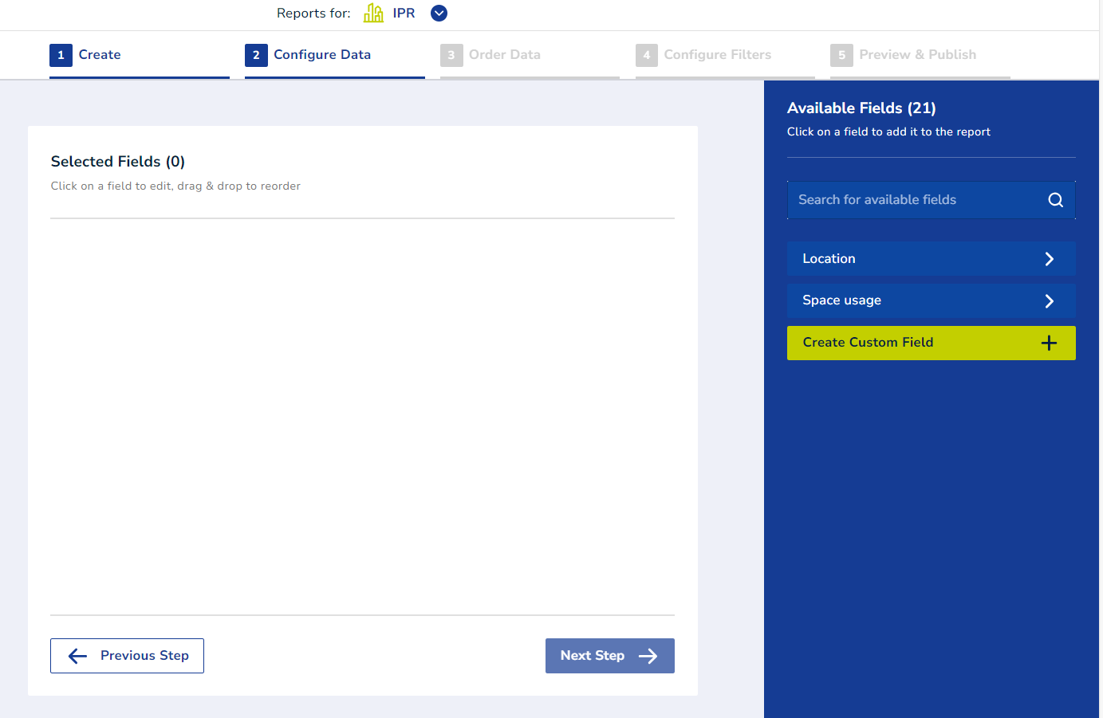
Once you found the column that you want, add it to your report by clicking on it. You’ll see all the selected fields at the centre of the page. At this stage, you can change the order of the columns by dragging and dropping the selected fields.
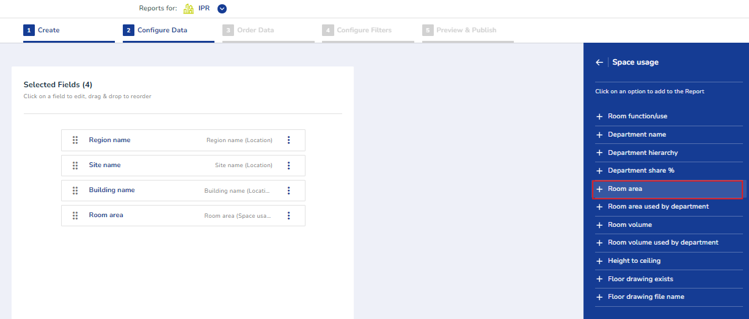

Editing a field

The three dots next to the column names contains configuration options such as Edit, Duplicate and Delete.
To change the name of the column, click on the three dots next to the desired field and select ‘Edit’.
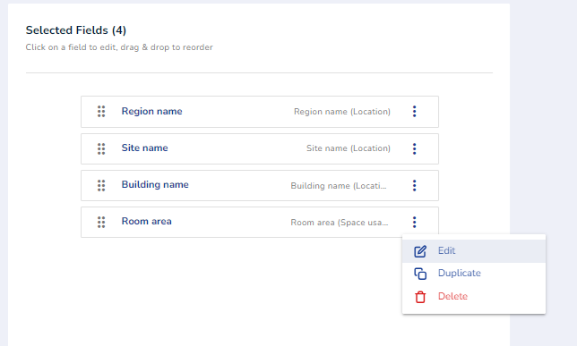
This will take you to the right-hand side menu, where you can edit the column header.
Once you are happy with the column name, click Save and the column name will update in the selected fields section.
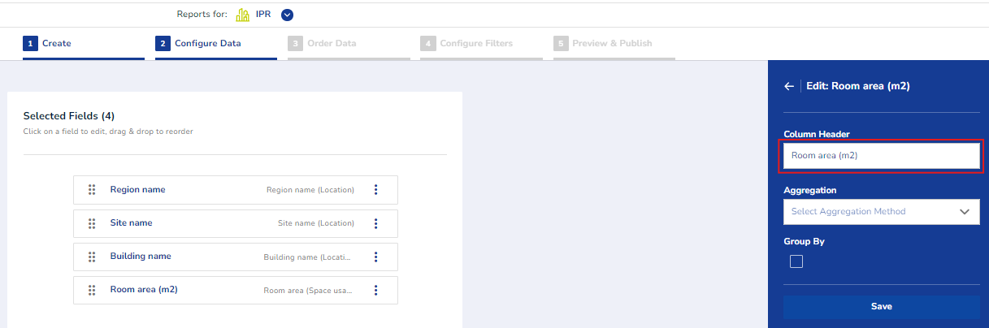

Aggregating a field

While editing the field, you can also apply an aggregation to it depending on the type of the field. The rules are as follows:
Aggregation types available for number type fields:
- Count
- Count distinct
- Average
- Minimum
- Maximum
- Sum
For text and date fields:
- Count
- Count distinct
- Minimum
- Maximum

When applying an aggregation to a field, all the other fields will automatically be grouped. This is shown by the Group by tag.
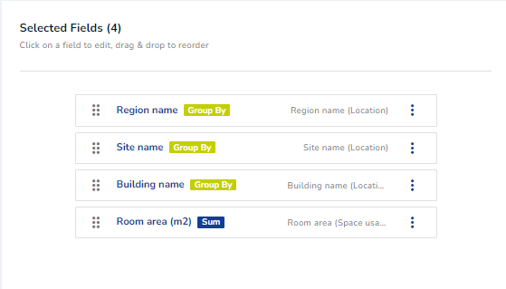

Creating a custom field

On the right-hand side menu, you can opt to create a custom field by clicking ‘Create custom field’. This will bring a popover window up.
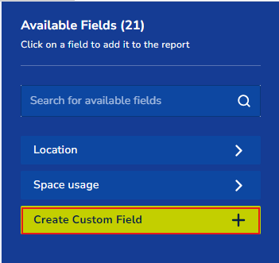
On the popover window, add the field name and the formula, then click Save.
Note. Make sure you don’t inadvertently click outside the popover window by mistake, this aborts the wizard immediately and any input is lost.

Formulas can be:

Static text
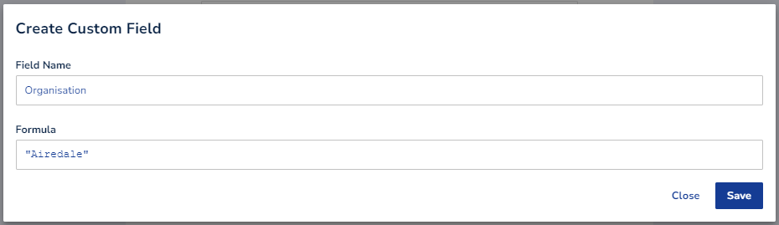
Note: use quotation marks when adding text to the custom field.

Calculation

Use numbers or pre-existing fields. Operations available are addition (+), subtraction (-) , multiplication (*) and division (/).
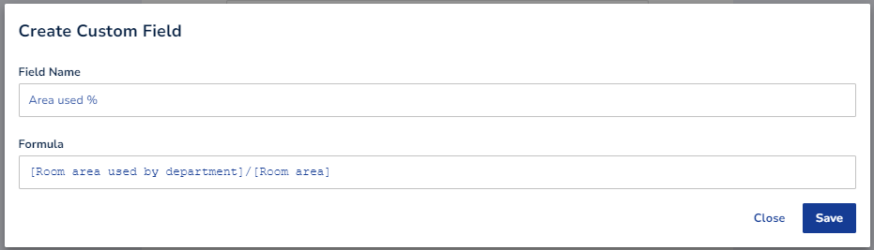

Formula

There is a set of pre-defined formulas, they will come up as you start typing. In this example, we’ll use CONCAT() to display two fields in the same column, separated by a comma.
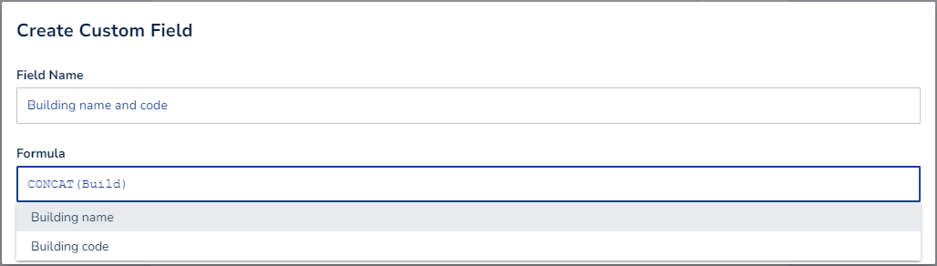
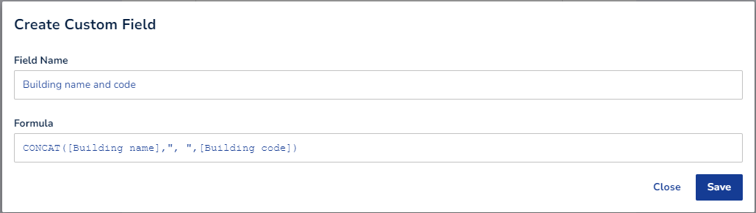
Note: The formula used in this example: CONCAT([Building name],”, “,[Building code])
If there are any typos or the data type used in the formula is not correct, a message error will come up and you won’t be able to save the custom field until the issue is fixed.
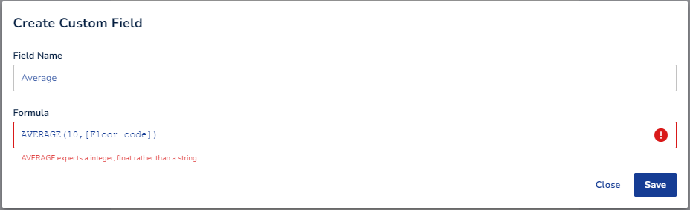
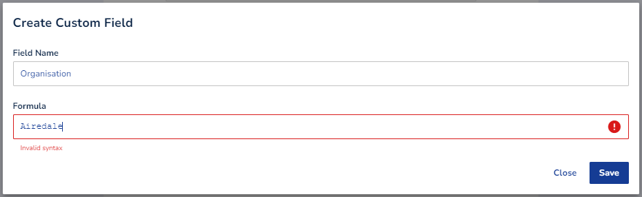
The available formulas are:
For data type number:
ABS: Returns the absolute value of a number, example: 'ABS(-5)' = 5
FLOOR: Rounds a number down to the nearest whole number, example: 'FLOOR(10.4)' = 10
ROUND: Rounds a number to the nearest given number of decimal places or to the nearest whole number if a precision is not specified, example: 'ROUND(4.63, 1)' = 4.6
CEILING: Rounds a number up to the nearest whole number, example: 'CEILING(54.1)' = 55
MIN: Returns the minimum value in a set, example: 'MIN([Temperature], 20)'
MAX: Returns the largest value in a set, example: 'MAX([Number of floors], 2)'
AVERAGE: Returns the average of a set, example: 'AVERAGE(3.9, 5.47)' = 4.685
POWER: Raises a base by an exponent, example: 'POWER(3, 2)' = 9

Date: (example [Scheduled Date] = 31/01/2024)
YEAR: Returns the year component of a date, example: 'YEAR([Scheduled Date])' = 2024
MONTH: Returns the month component of a date, example: 'MONTH([Scheduled Date])' = 1
DAY: Returns the day component of a date, example: 'DAY([Scheduled Date])' = 31

Text
CONCAT: Joins multiple values together into a single string, example: 'CONCAT("Hello ", [Username])'

Editing a custom field

To edit your custom field, select the Custom folder on the right-hand side menu and click on the Edit button, this will bring up the popover window. Edit your field and click Save.

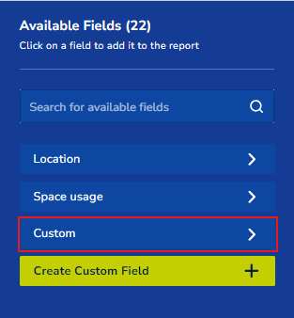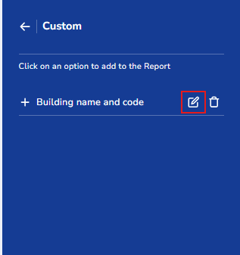

Using a custom field

Add your custom field to your report by clicking on it on the right-hand side menu.
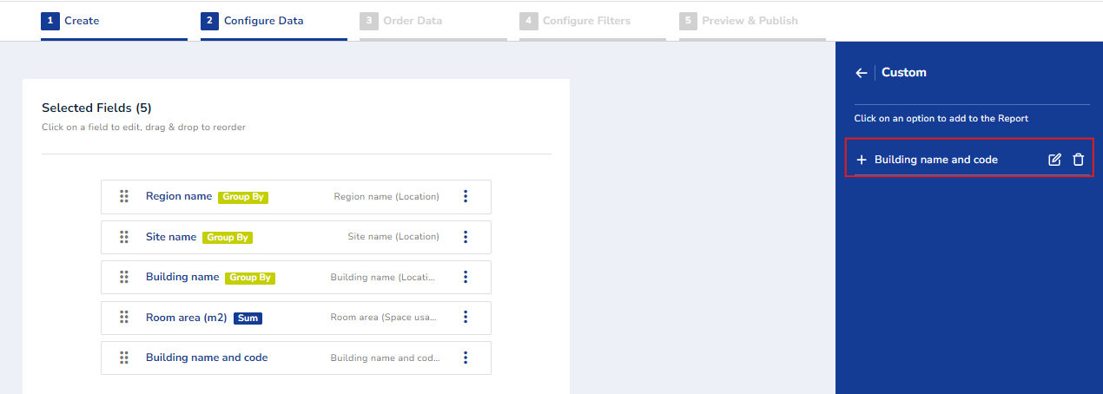

Rearrange fields if necessary and click Next step.

Order data

Select the fields on the right-hand side menu and the order they should follow in the report. Then click Next step.
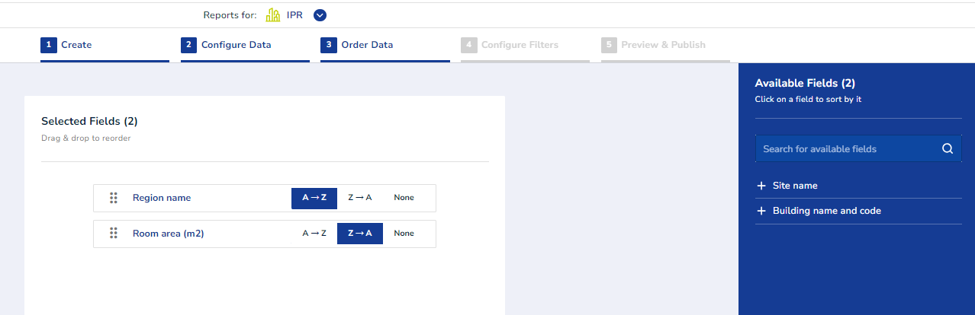

Configure filters

In this step you can select fields that will be the parameters of your custom report. These can be filled when running the report later on.
Select the fields from the menu on the right-hand side, then arrange them in your desired order on the report page by dragging and dropping the selected fields.
Once done, click Next Step.
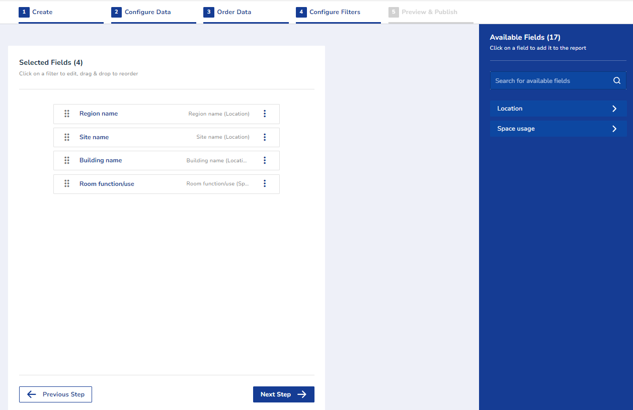
This is what these parameters will look like on the report page:
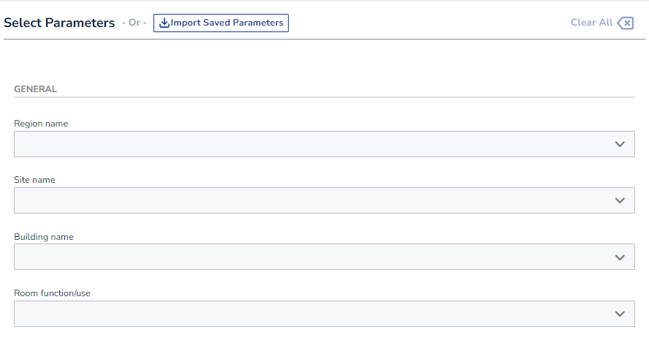

Preview & publish

In this final step of creating your custom report, you'll see a preview of the report. If any changes are needed, you can click Previous Step to go back and adjust the report configuration.
Once you're satisfied with the preview, click Save to finalize the report.
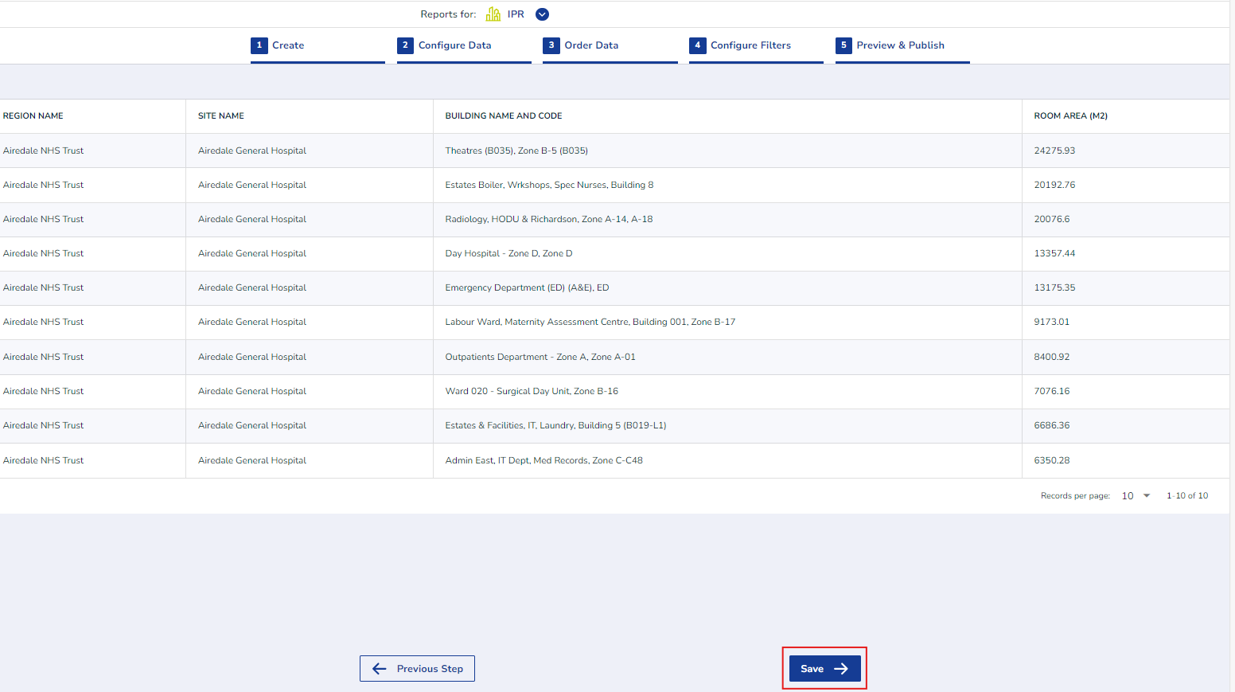
A success message will appear, allowing you to either close the Designer wizard or proceed to create another report.
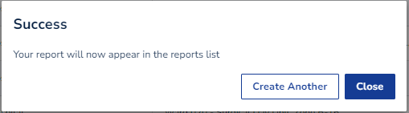

Generate your Designer report

The custom report you created will appear in the report tree on the left-hand side menu, under the topic you selected. Custom reports are marked with a star icon for easy identification.
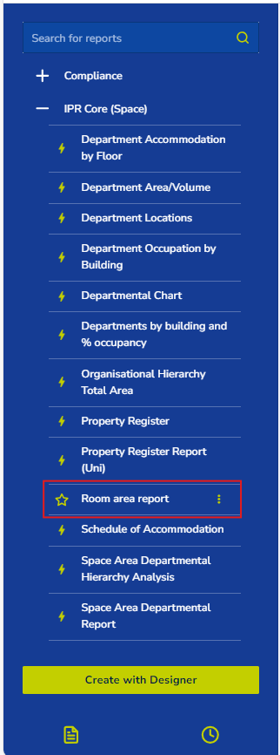

This custom report can now be run on demand or scheduled like any other report.
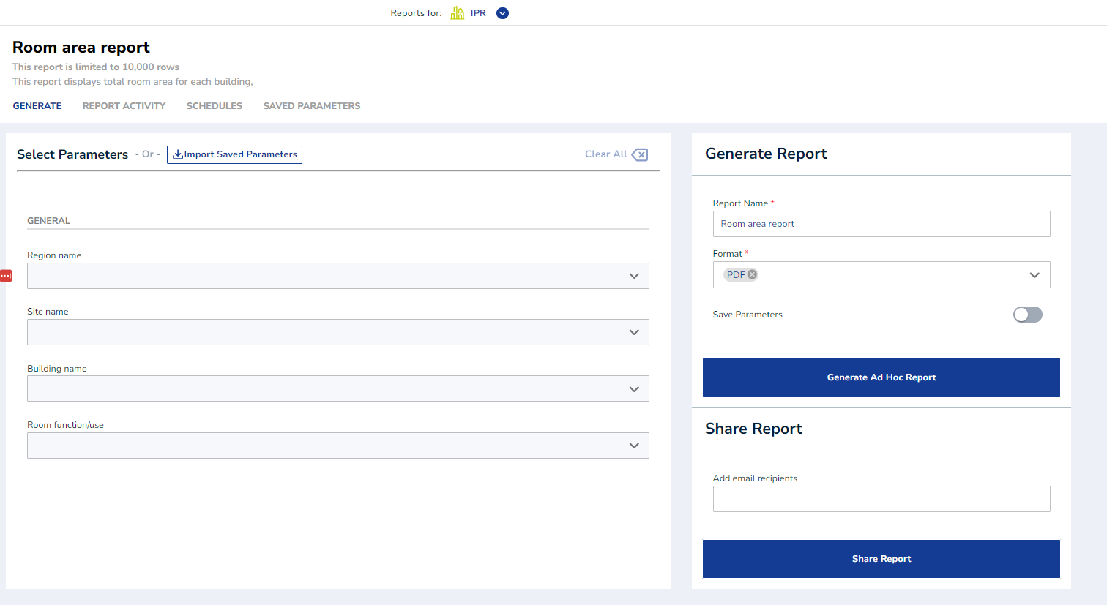

Available topics on the ‘Designer’

These are the topics currently available on the ‘Designer’:
- Asbestos
  - Asbestos Location Status
  - Asbestos Survey Item Status
  - Asbestos Current Inspection
  - Asbestos Events
  - Asbestos Remedial Actions
- Leases
- Terrier
- Compliance
- IPR Core
  - Documents
  - Space Usage
- Fire Incidents
  - Incidents
  - Action Points
- Fire Risk Assessment
  - Open Action Points

Release notes

04/10/2024 PRO

API version 1.0.22485 to 1.0.22918
12774 FM report: Resource Timesheet Enhanced feedback
13373 SFM report: Add 'Custom Form Output' report to micadpro
13418 Terrier 'Designer' topic bug fix
13392 Use default parameter value provided in yml
12257 Make CSV An Option for Export (non-default)

20/01/2025 PRO

UI version 1.0.22476 to 1.0.23652
API version 1.0.22939 to 1.0.23695
13693 Improvement to "Asbestos register printer QR labels”
13507 Users by module (new users report)
11596 PPM Remedials Report (new FM Report)
13512 Index values shown in dropdowns (bugfix)
13013 DoH Risk based Backlog Appendix 5 Report (new report)
13511 Add validation for selected date
13504 Multi-select parameters 'All', 'None' options

14/05/2025 PRO

UI version 1.0.23652 to 1.0.25423
API version 1.0.23695 to 1.0.25482
13019 Designer: Report description disappears when editing existing report bug fix
13391 Differentiate appraisal module SAMS/PRO
13396 Modify SFM reports for csv format
13567 New SFM Report - Pie Chart Total Tasks per Resource Group
13604 Report parameter 'Clear all' function bug fix
13797 Report Designer [micadsams.net] Radio button for permission doesn't work
13830 Asbestos register printer QR labels
13850 SFM reports update micadpro
13870 Remove html format from scheduled report emails
13891 Update SFM - Location/Activity Analysis report for MicadPro
13892 Update SFM - Location Activity Analysis report for MicadPro
13893 Update SFM - Request History report for MicadPro
13894 Update SFM - Resource Delays report for MicadPro
13895 Update SFM - Resource Traceability report for MicadPro
13896 Update SFM - Summary Analysis report for MicadPro
13897 Update SFM - Task Data report for MicadPro
13898 Update SFM - Task Per Resource Group report for MicadPro
13935 Update reports release notes link
14051 Deal with out of memory errors
14053 Designer: sort folder and fields alphabetically
14105 DoH Risk based Backlog Appendix 5 Report cosmetic change
14109 Multi-select parameter refactor
14758 Micadpro: User Activity bug fix
14852 NHSS Multi-select parameter bug fix
14959 RUM reports - remove database references
14986 RUM reports - SQL terminated (departmentPath)
14987 RUM Audit Booking Report - update Client parameter list
15065 Cancelled audit report feedback: remove Responsibility group parameter
15163 Reports Micadpro: Room Booking report date bug
15222 RUM Audit Booking Report - improve performance
15408 Rename Application "Room Utilisation" to "MiBooker" Across UI and Configuration

END

